CC1:

OUESTION1:

CODE:

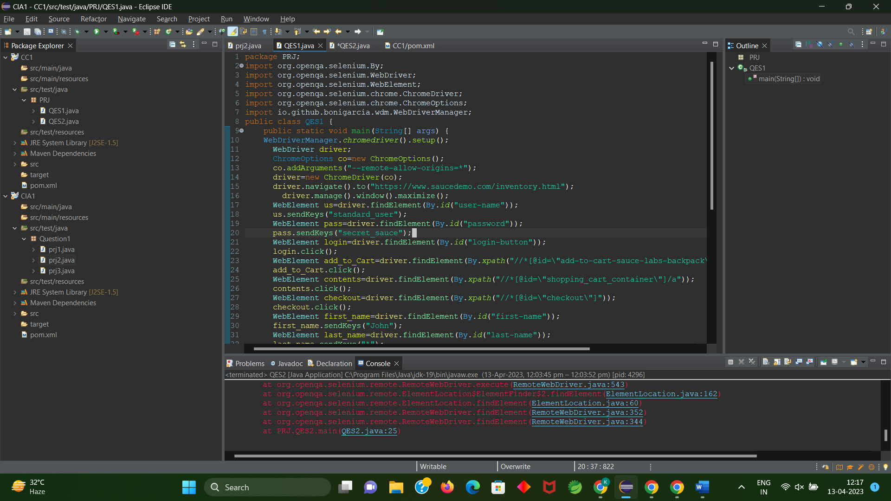

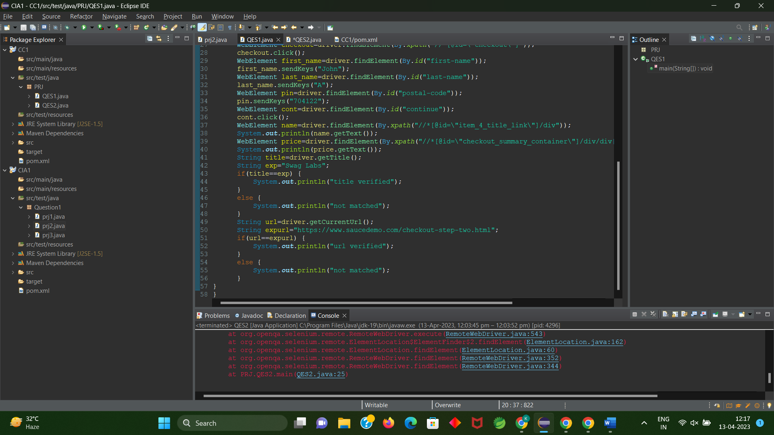

OUTPUT:

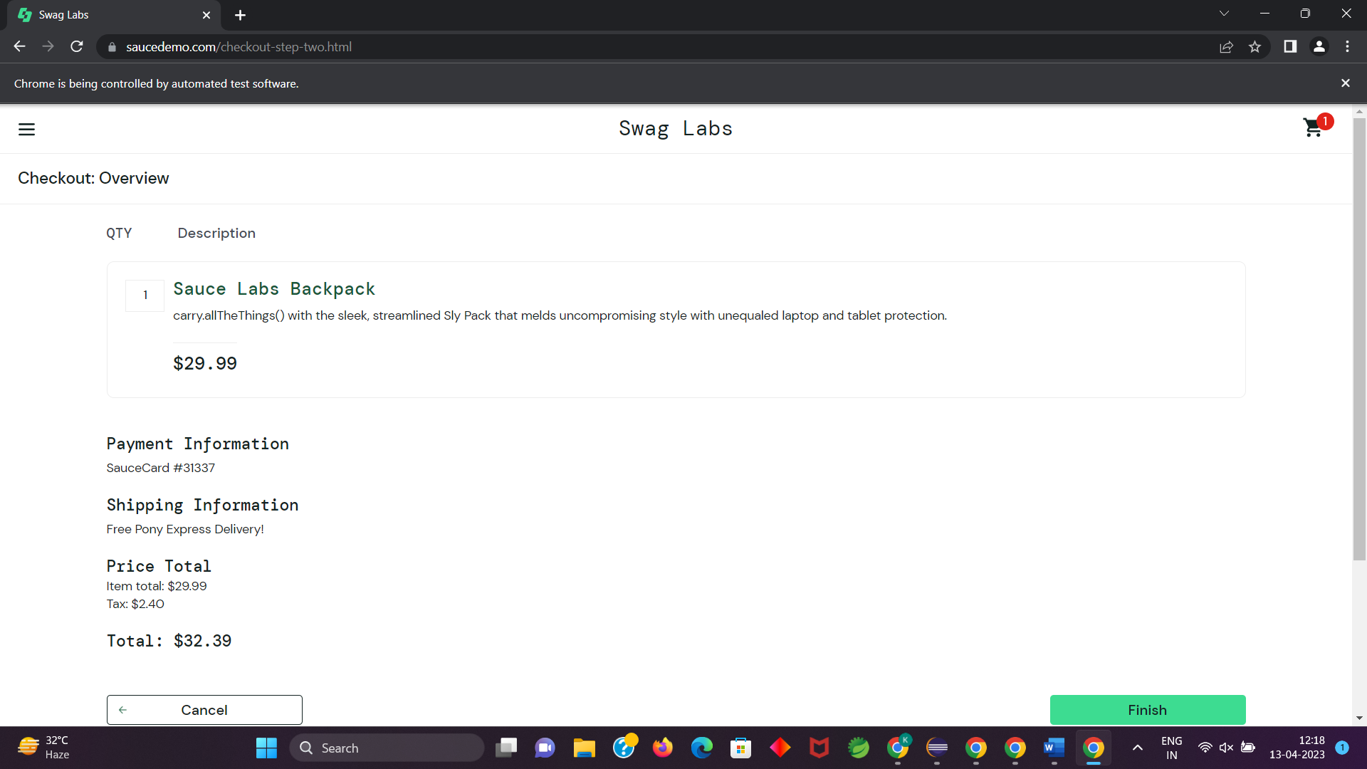

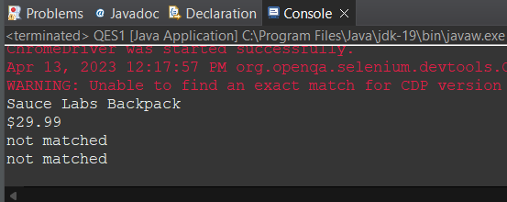

QUESTION2:

CODE:

package com.demo.Demo;

import org.openqa.selenium.By;

import org.openqa.selenium.WebDriver;

import org.openqa.selenium.WebElement;

import org.openqa.selenium.firefox.FirefoxDriver;

import org.openqa.selenium.support.ui.Select;

import io.github.bonigarcia.wdm.WebDriverManager;

public class task2 {

public static void main( String[] args ) throws InterruptedException

{

WebDriverManager.*firefoxdriver*().setup();

WebDriver driver = new FirefoxDriver();

driver.manage().window().maximize();

driver.navigate().to("https://www.saucedemo.com/");

driver.manage().window().maximize();

WebElement txtBoxl=driver.findElement(By.*xpath*("//*[@id=\"user-name\"]"));

txtBoxl.sendKeys("standard_user");

WebElement txtBox2=driver.findElement(By.*xpath*("//*[@id=\"password\"]"));

txtBox2.sendKeys("secret_sauce");

driver.findElement(By.*xpath*("//*[@id=\"login-button\"]")).click();

String txt1=driver.findElement(By.*xpath*("//*[@id=\"item_4_title_link\"]/div")).getText();

System.***out***.println(txt1);

driver.findElement(By.*xpath*("//*[@id=\"header_container\"]/div[2]/div/span/select")).click();

driver.findElement(By.*xpath*("//*[@id=\"header_container\"]/div[2]/div/span/select/option[2]")).click();

String txt2=driver.findElement(By.*xpath*("//*[@id=\"item_3_title_link\"]/div")).getText();

System.***out***.println(txt2);

driver.findElement(By.*xpath*("//*[@id=\"header_container\"]/div[2]/div/span/select")).click();

driver.findElement(By.*xpath*("//*[@id=\"header_container\"]/div[2]/div/span/select/option[3]")).click();

String txt3=driver.findElement(By.*xpath*("//*[@id=\"item_2_title_link\"]/div")).getText();

System.***out***.println(txt3);

driver.findElement(By.*xpath*("//*[@id=\"header_container\"]/div[2]/div/span/select")).click();

driver.findElement(By.*xpath*("//*[@id=\"header_container\"]/div[2]/div/span/select/option[4]")).click();

String txt4=driver.findElement(By.*xpath*("//*[@id=\"item_5_title_link\"]/div")).getText();

System.***out***.println(txt4);

Thread.*sleep*(5000);

}

}

OUTPUT:

